1. Run **ActiveReportsDemo\Database\CreateTestDB.sql** file to create test DB.
2. Add **Report Explorer 13** window to Visual Studio. 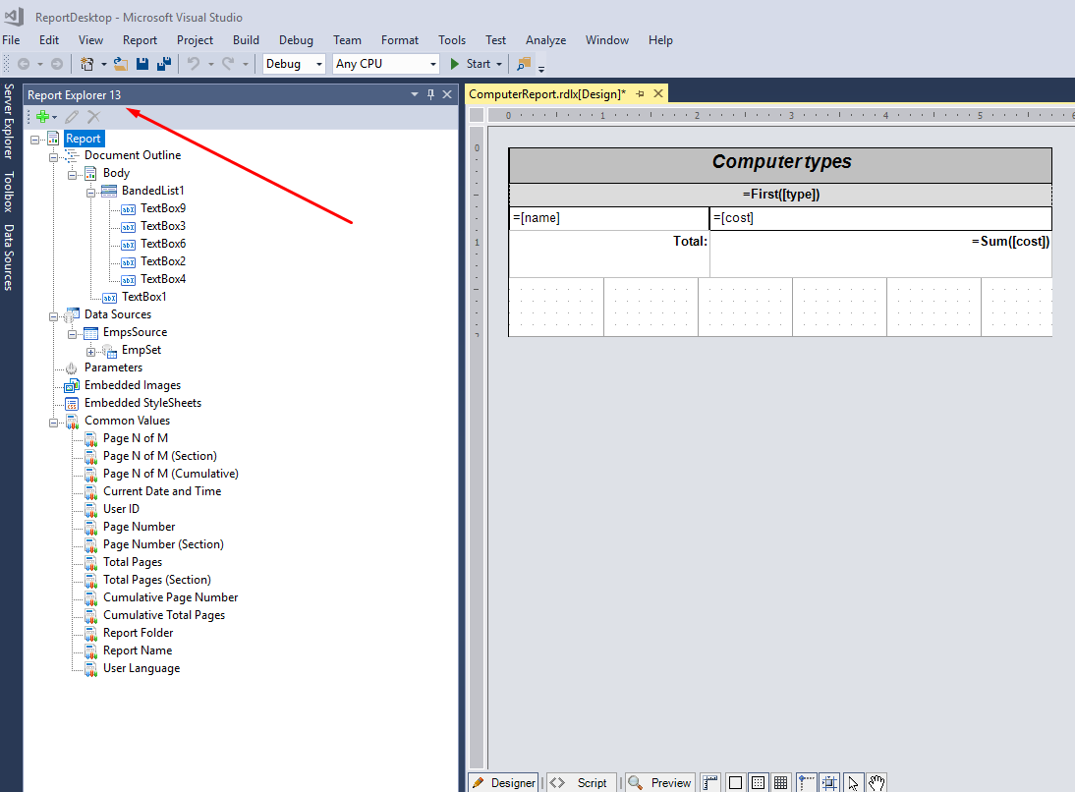
3. Right click on **EmpsSource** and select **Edit**.
4. Type your SQL server name or ‘localhost’ at **Server name:** and press **OK**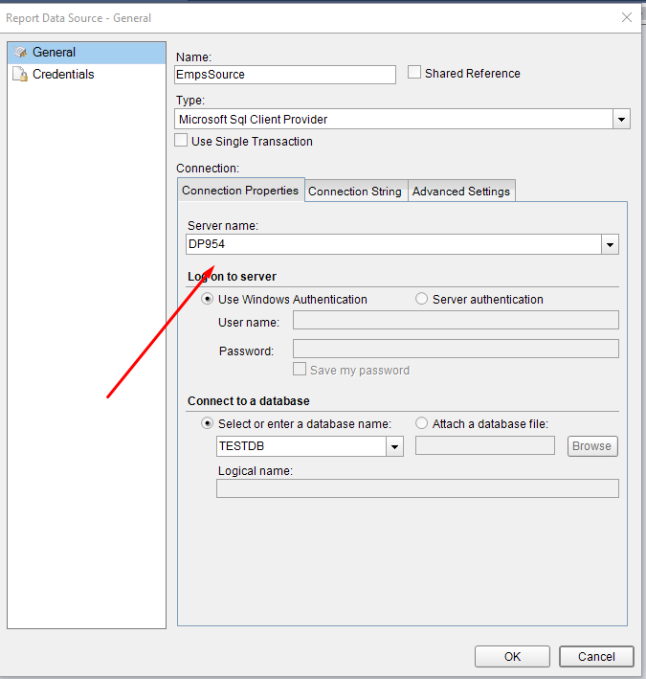
5. Compile solution and run it